Disqus Comment Document

## DISQUS – The Web’s Community of Communities

## Disqus is a free service that enables great online communities. As the web’s most popular discussion system. Disqus is used by millions of websites that cover pretty much any topic imaginable. Our magic is in connecting people to stuff worth talking about.

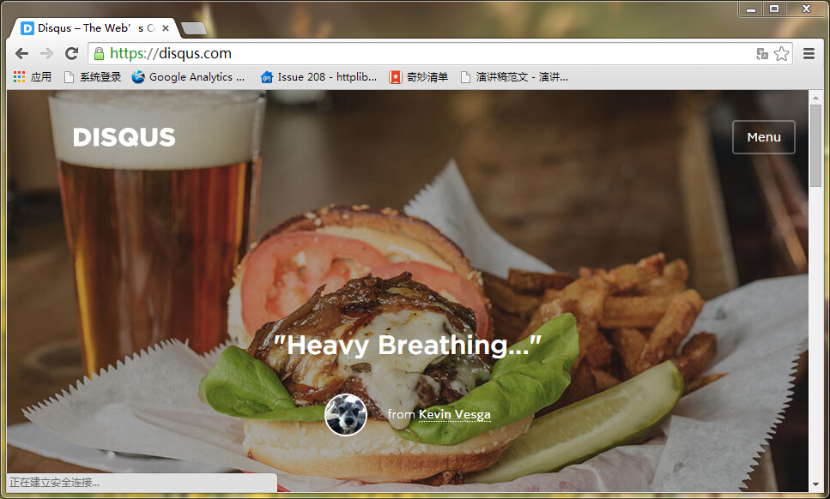

**Disqus Account**

**URL**: <https://disqus.com>

**Email**: [disqus@missionsky.com](mailto:disqus@missionsky.com)

**Email Password**: civicdata#123

**Account**: civicdata

**Password**: civicdata#123

**Configuration Disqus**

It is easy to manage all user’s comments and provide a simple user’s comments analysis. Also you can modify the settings at necessary.

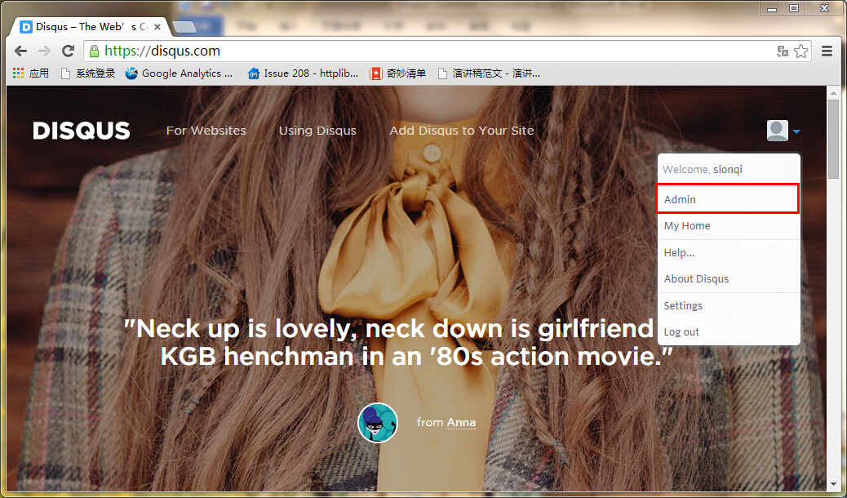

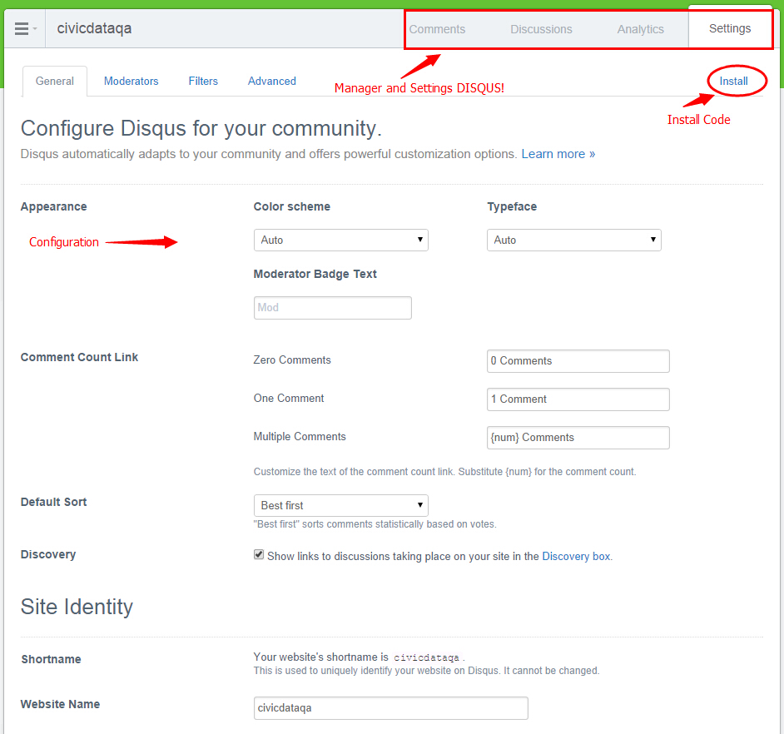

**View the Comments**

